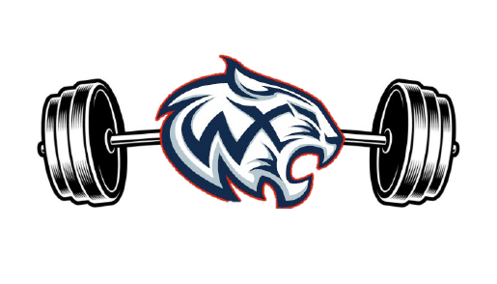

WOODS CROSS STRENGTH AND CONDITIONING

The Mission of the Woods Cross Strength and Conditioning program is to promote growth and development (Physically/Mentally), to teach proper technique, offer sound nutritional feedback and ensure durability and injury prevention. It is the objective of the S & C program to provide the Woods Cross Football program, and its athletes a comprehensive plan to achieve all strength and conditioning goals. We will provide our student athletes with the means to train with intensity, commitment, desire, discipline and dedication while maintaining teamwork throughout.

